›‘~.{’ *Sustainable Smart City*

Assistant

**Team Name: GreenTech Solo Labs**

Team ID : LTVIP2025TMID34894

Team Member:

*NAME : MANIGANTI LAKSHMI SAILAJA*

*Register Number:*

*Hall Ticket No.: 22ND1A4287*

*College: ST MARY’S WOMENS ENGGINEERING COLLEGE*

|)› ‘ **Table of Contents**

|  |  |  |
| --- | --- | --- |
| **S. No.** | **Section Title** |  |
| **1.** | Introduction |  |
| **2.** | Ideation Phase |  |
| **3.** | Requirement Analysis |  |
| **4.** | Project Design |  |
| **5.** | Project Planning & Scheduling |  |
| **6.** | Functional and Performance Testing |  |
| **7.** | Results |  |
| **8.** | Advantages & Disadvantages |  |
| **9.** | Conclusion |  |
| **10.** | Future Scope |  |
| **11.** | Appendix |  |
|  | Source Code, Dataset Link, GitHub & Project Demo Link |  |

# INTRODUCTION

## Project Overview

Cities today are facing growing environmental issues such as unmanaged waste, excessive energy consumption, and limited citizen involvement in sustainability. Many existing systems are either manual, outdated, or lack engagement.

To address this, the **Sustainable Smart City Assistant** was developed—an AI-powered application built using **Streamlit** and **IBM Granite 3.3-2B Instruct** model. It provides practical, real-time assistance in areas like:

* + - Waste sorting guidance
    - Energy-saving recommendations
    - Policy document summarization
    - Forecasting and anomaly detection in utility data
    - Collecting citizen feedback
    - Offering eco-tips and green challenges

All features are integrated into a user-friendly Gradio interface hosted on

**Google Colab**, making the solution lightweight, scalable, and easy to

access. The tool is designed to promote sustainable urban living through technology.

## Purpose

The main purpose of this project is to support eco-friendly choices and smarter city planning through an intelligent assistant.

Key objectives include:

* + - Educating users on sustainability topics
    - Providing actionable, personalized recommendations
    - Simplifying complex urban policies
    - Automating feedback collection and resource analysis
    - Promoting daily eco-friendly habits

This tool bridges the gap between AI and civic engagement, encouraging users to make more informed, sustainable decisions in daily life.

# IDEATION PHASE

## Problem Statement

Urban areas are under increasing pressure from challenges like poor waste management, inefficient energy use, and low public engagement in

sustainable practices. Despite the availability of policies and initiatives, most citizens are either unaware of them or find them too complex to act upon. A lack of accessible digital tools that guide and assist in sustainable behavior further widens the gap.

## Empathy Map Canvas

To better understand the needs of target users, an empathy map was created based on the following key aspects:

**Says**: "I want to help the environment but don't know how."

* + - **Thinks**: "Sustainability tools are usually too complex."
    - **Does**: Uses electricity, throws waste without sorting, reads news online
    - **Feels**: Overwhelmed by city issues, unsure about making a difference

This helped identify opportunities to simplify sustainability through digital assistance.

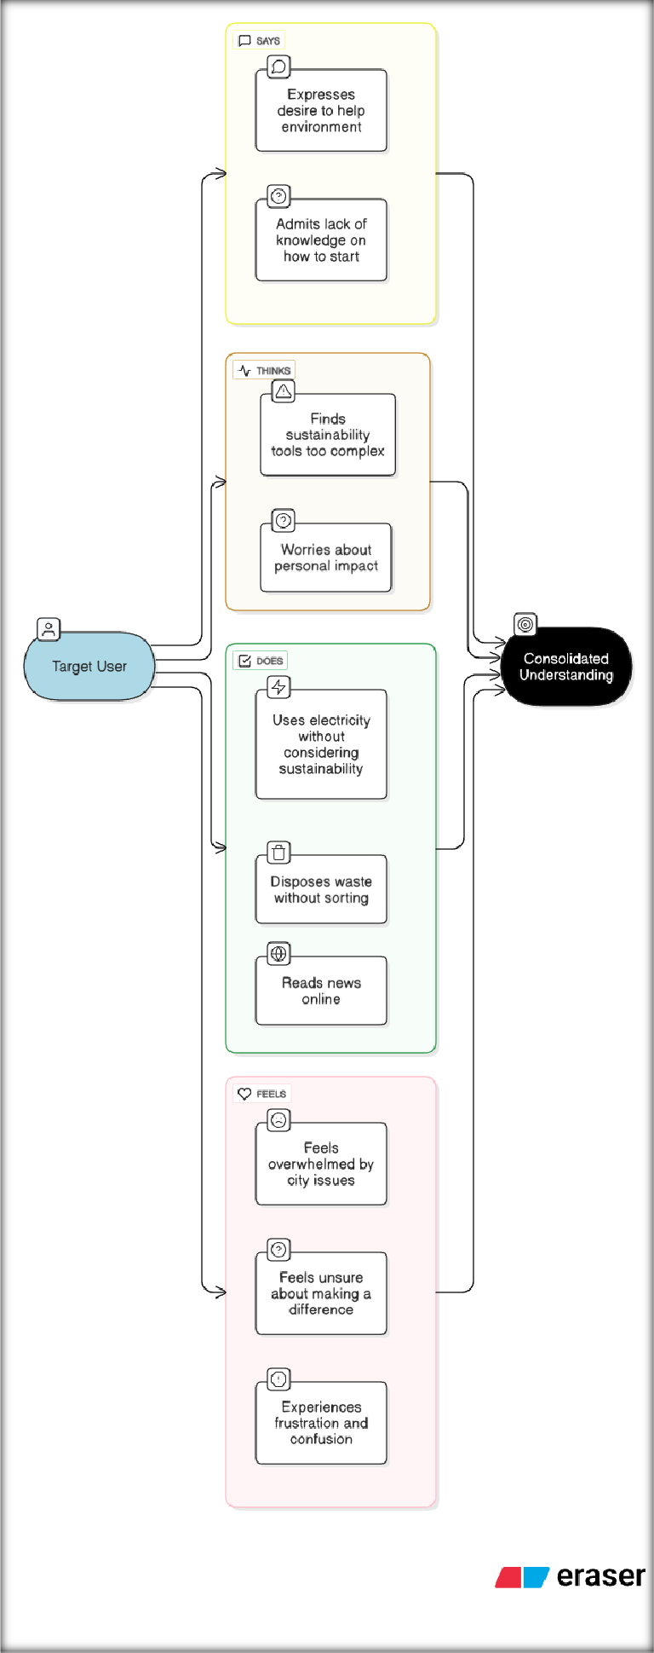

## Brainstorming

Initial brainstorming sessions focused on combining artificial intelligence

with urban sustainability. Ideas were generated around making the system:

* + - **Conversational** (natural language-based)
    - **Modular** (separate tools for waste, energy, policy, etc.)
    - **Actionable** (providing tips, summaries, and forecasts)
    - **Accessible** (no installation, simple UI)

The final idea evolved into a smart assistant using **Gradio for interface** and **IBM Granite for AI-powered responses**, deployed conveniently via Google Colab.

## Customer Journey Map

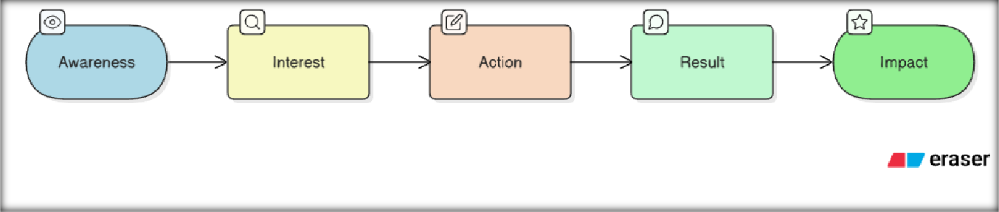

To ensure user-centric design, a simple journey map was created:

* + - **Awareness**: User learns about the assistant via demo or campaign
    - **Interest**: Visits the tool to explore features
    - **Action**: Inputs data or questions (e.g., waste item, energy habits)
    - **Result**: Receives personalized AI-driven response
    - **Impact**: Learns, improves habits, or contributes civic feedback This helped shape the feature layout and interface flow.

## Solution Requirements

The tool was designed to offer the following core functionalities:

* + - Waste disposal and recycling guidance
    - Energy usage analysis and tips
    - Sustainability Q&A chatbot
    - Policy text summarization
    - Forecasting of utility consumption via CSV
    - Anomaly detection in uploaded data
    - Green challenge generator
    - Citizen feedback collection and download

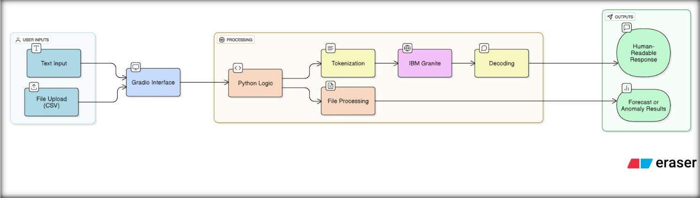

Each feature is designed to be modular, easy to use, and relevant to sustainable city living.

## Data Flow Diagram (DFD)

The basic system flow is as follows:

## User Input → Gradio Interface → AI Model / Python Logic → Response Output

* + - File Uploads (CSV) → Processed by Python → Forecast or Anomaly Results
    - Text Inputs → Tokenized → Sent to IBM Granite → Decoded into human-readable response
  1. **Technology Stack**

|  |  |
| --- | --- |
| **Layer** | **Tools / Libraries Used** |
| **Language** | Python |
| **Frontend** | Gradio (UI components, Tabs, Inputs, Buttons) |
| **Backend** | Custom Python Functions + IBM Granite 3.3-2B Instruct |
| **AI Model** | IBM’s open Granite family (via HuggingFace Transformers) |
| **Data** | CSV files, User text inputs |
| **Hosting** | Google Colab + Pyngrok for sharing public link |
| **Storage** | Feedback data saved as Excel using pandas + openpyxl |

# PROJECT DESIGN

## Problem-Solution Fit

This project directly addresses key sustainability pain points faced by urban residents:

|  |  |
| --- | --- |
| **Problem** | **Solution** |
| **Waste disposal confusion** | AI-powered waste sorting assistant |
| **High energy consumption** | Personalized energy-saving tips |
| **Lack of eco-awareness** | Daily green challenges and Q&A support |
| **Complex policies** | Summarization of documents in simple terms |
| **Untracked utility trends** | Forecasting and anomaly detection with CSVs |
| **Low civic engagement** | Easy citizen feedback collection and storage |

The assistant turns challenges into actionable insights using a conversational approach.

## Proposed Solution

The solution is an **AI-driven, modular web assistant** that allows users to interact with sustainability features from a single, easy-to-use Gradio interface. Instead of creating multiple apps, all services are built as

**individual tabs** with clean UI components and connected to a powerful language model (IBM Granite).

Core modules include:

* + - Waste Sorting
    - Energy Advisor
    - Policy Expert
    - Feedback Collector
    - Forecasting & Anomaly Detection

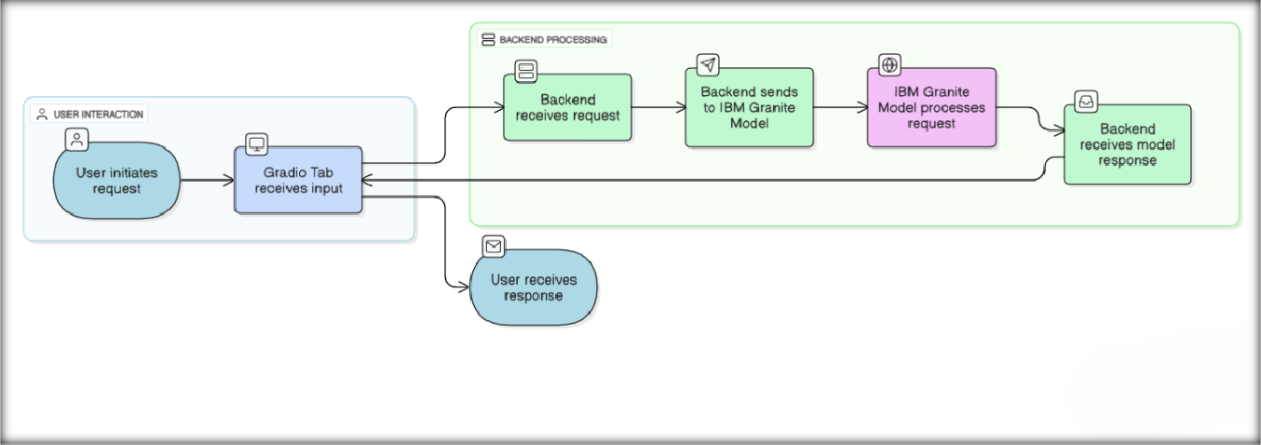

* + - Sustainability Chatbot
    - Eco Tips & Green Challenge Generator

## Solution Architecture

Here’s how the system works:

* + - **Frontend**: Gradio for layout and user interaction
    - **Model Integration**: IBM Granite via Hugging Face Transformers
    - **Logic Layer**: Python functions for processing, summarizing, forecasting, etc.
    - **Output**: Displayed or downloadable results (e.g., Excel for feedback)

# PROJECT PLANNING & SCHEDULING

## Project Planning

The project followed a milestone-based Agile workflow, divided into structured sprints to ensure steady progress within the given timeline of **May 26 to June 25, 2025**. Being a solo project, planning and execution were done independently with careful task prioritization.

## Sprint-wise Breakdown

|  |  |  |
| --- | --- | --- |
| **Sprint** | **Focus Area** | **Tasks Covered** |
| **Sprint 1** | Setup & Initialization | Finalizing problem statement, Colab environment setup, installing  dependencies |
| **Sprint**  **2** | Core Feature  Development | Waste sorting assistant, energy advisor,  policy summarization, eco challenges |
| **Sprint**  **3** | Advanced Modules | Forecasting and anomaly detection via  CSV files |
| **Sprint**  **4** | Feedback Module &  File Integration | Citizen feedback form, Excel export  functionality |
| **Sprint**  **5** | AI Chat Assistant + UI  Enhancements | Sustainability Q&A chatbot, Gradio  tabbed layout, enhanced CSS |
| **Sprint 6** | Final Testing & Submission  Preparation | Debugging, file handling, test cases, documentation, and demo video  creation |

†*^ˆ^-’˙^ .z-¸,˙˜ˆ **Task Allocation**

**Madduru Mani Teja (Solo Developer)**

**– Responsible for end-to-end development, UI design, testing,**

**documentation, and deployment.**

●'−◯· **Project Timeline**

|  |  |
| --- | --- |
| **Milestone** | **Date Completed** |
| **Requirements Finalized** | May 26, 2025 |
| **Setup & Model Integration** | May 28, 2025 |
| **Core Features Completed** | June 5, 2025 |
| **Forecasting & Anomaly Features** | June 10, 2025 |
| **Feedback & Chatbot Module** | June 15, 2025 |
| **Final Integration & Testing** | June 20, 2025 |
| **Report & Presentation Ready** | June 24, 2025 |
| **Final Submission** | June 25, 2025 |

# FUNCTIONAL AND PERFORMANCE TESTING

## Performance Testing

The Sustainable Smart City Assistant was tested in **Google Colab** with the

**IBM Granite 3.3-2B Instruct model** integrated through Hugging Face.

Performance and stability were key priorities given the AI-driven response generation and file handling.

⬛ **Functional Test Cases**

|  |  |  |  |
| --- | --- | --- | --- |
| **Module** | **Test Scenario** | **Expected Outcome** | **Result** |
| **Waste Sorting** | Input: “Banana  peel” | Suggests composting or  biodegradable disposal | Passed |
| **Energy Advisor** | Input: “Leave fan on  overnight” | Recommends switching off unused appliances | Passed |
| **Policy Expert** | Input: Sample EV policy  document | Generates 3–5 citizen- friendly key points | Passed |
| **Resource Forecasting** | Upload: CSV with "usage"  column | Forecasts next-period usage with +10% projection | Passed |
| **Anomaly Detection** | Upload: CSV  with outlier values | Identifies values beyond ±2 SD from mean | Passed |
| **Feedback**  **Submission** | Input: Issue text  and category | Saves to Excel and confirms  log | Passed |
| **File Download** | Click download button after  feedback is saved | Downloads  smart_city_feedback.xlsx | Passed |
| **Sustainability Chatbot** | Input: “How to reduce plastic in  cities?” | AI returns informative, conversational answer | Passed |
| **Green**  **Challenge** | Click challenge  button | Returns one random eco-  challenge | Passed |
| **Eco Tips** | Input: “Solar  panels” | Provides 3 useful tips for city  residents | Passed |

**Bug Fixes & Improvements**

|  |  |
| --- | --- |
| **Issue** | **Fix Implemented** |
| **Long output getting truncated** | Increased max_length in model  response |
| **File error for Excel output** | Added fallback for empty feedback  list |
| **Gradio layout overlapping on**  **mobile** | Adjusted column spacing and CSS  padding |
| **Colab timeout on long model**  **generation** | Optimized prompt size and reduced  token limit |

⬛ **Final Validation**

* All modules performed as expected
* AI-generated responses were contextually relevant
* CSV upload and file handling worked across multiple test cases
* The Gradio UI responded well on both desktop and mobile views

’•˙¸.s7 **Deployment**

* The app was deployed using **Gradio + Pyngrok** on **Google Colab**
* Link shared for testing and demonstration
* No external hosting required, ensuring free and fast access

# RESULTS

## Output Screenshots

Below are the results of various modules successfully executed in the Sustainable Smart City Assistant. The screenshots validate both the functionality and the user interface design.

## ‘z ’ 1. Waste Sorting Module

**Description:** Input an item (e.g., "Plastic bottle") and receive eco-friendly disposal instructions.

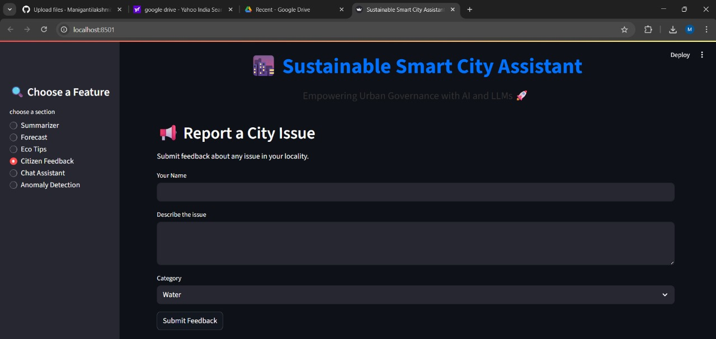

‘’z **2. Energy Advisor**

**Description:** Users describe their energy habits and get personalized suggestions.

## ‘ z’ 3. Policy Summarization

**Description:** Users paste policy text and receive simplified summaries in key points.

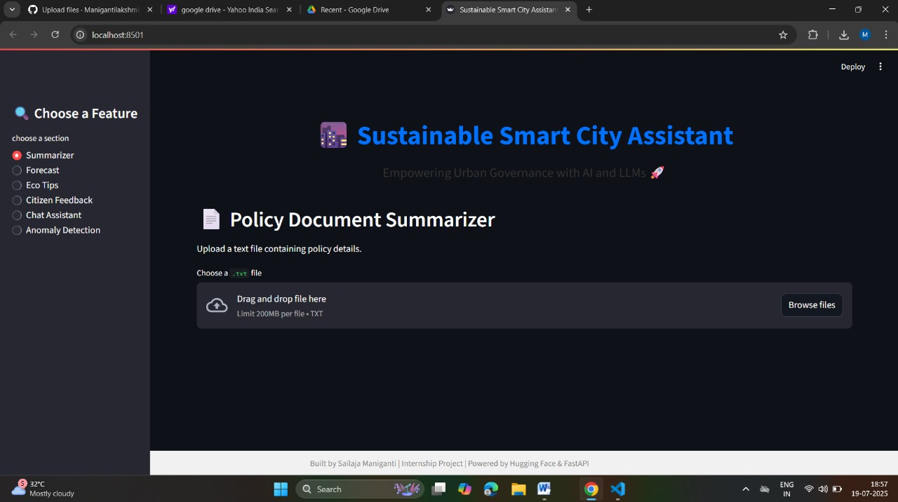

## z ‘’ 4. Forecasting Module

**Description:** Upload CSV with usage data and forecast the next period’s resource consumption.

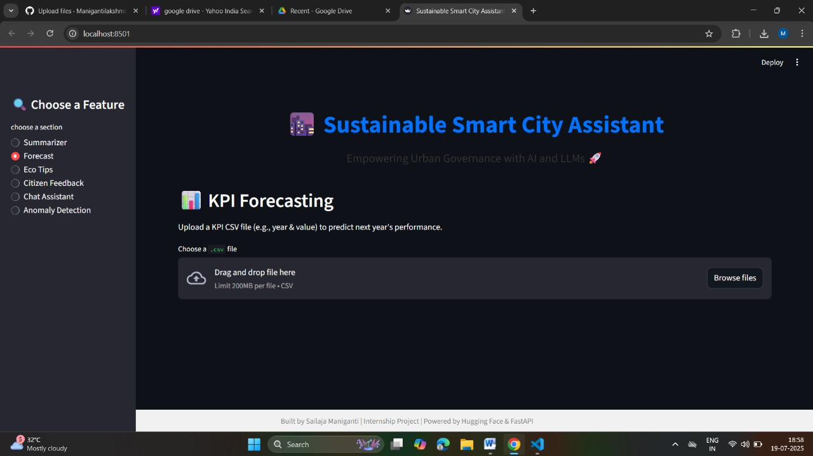z 5. Anomaly Detection

**Description:** Detects unusual data points in uploaded usage files using

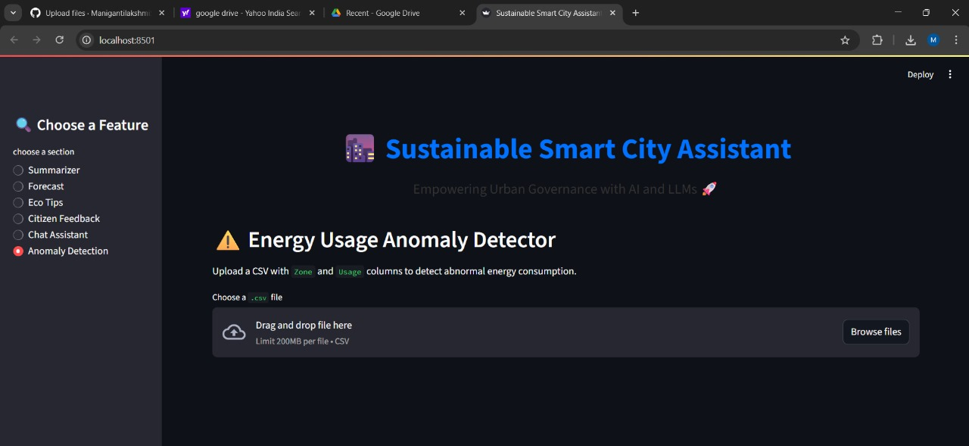

z ‘’ **6. Citizen Feedback**

**Description:** Users report civic issues and download feedback logs as an Excel file.



z ‘’ **7. Eco Tips**

**Description:** Tips for eco-friendly practices based on a keyword (e.g., "solar").

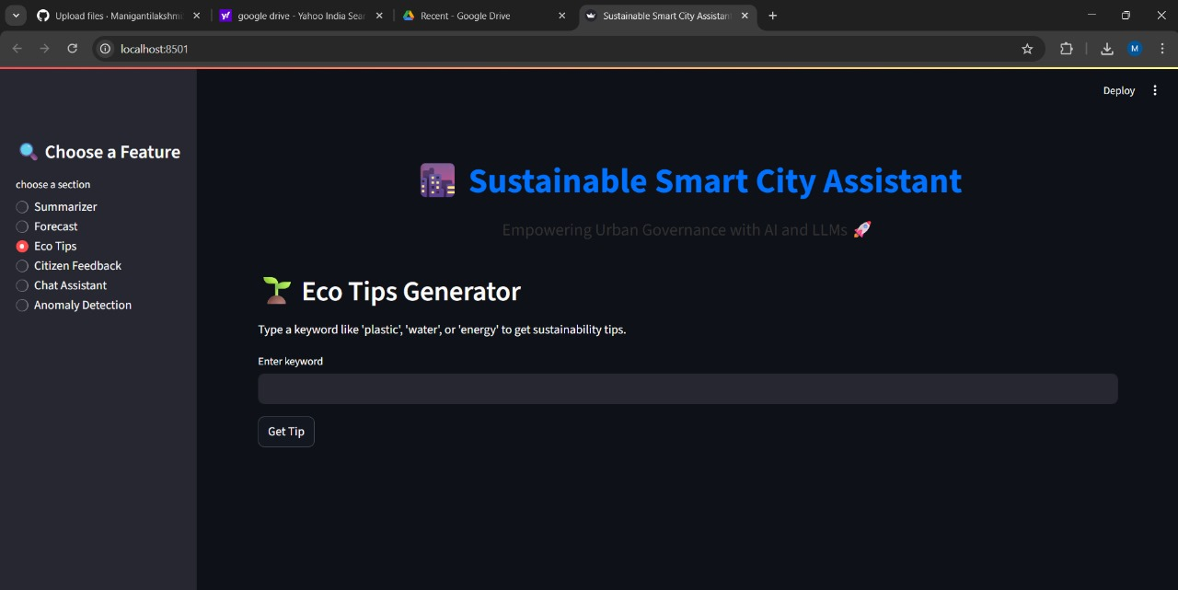

## ‘’z 9. Sustainability Chat Assistant

**Description:** Users ask questions like “How can my city reduce plastic?” and get AI responses.

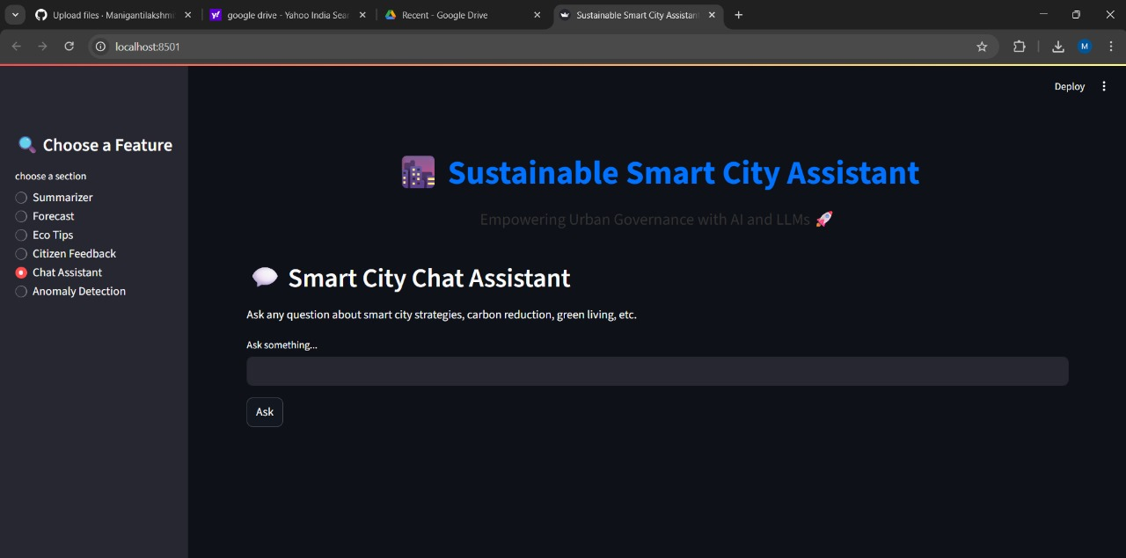

# ADVANTAGES & DISADVANTAGES

⬛ **Advantages**

## AI-Powered Assistance

The tool leverages IBM Granite to provide intelligent, real-time

suggestions and summaries, making sustainability approachable for everyone.

## Modular Interface with Gradio

The use of tabs keeps the UI organized and intuitive, offering a clean experience even with multiple functionalities.

## No Installation Needed

Hosted on **Google Colab** and accessible via **Pyngrok**, users can run the assistant from any browser without setup.

## Dynamic CSV Analysis

Upload-based forecasting and anomaly detection allow real-time resource monitoring for smart city planning.

## Citizen Engagement

Enables feedback logging and civic participation, encouraging users to report local issues constructively.

## Educational Value

Provides eco-tips, green challenges, and simplified policy summaries to boost awareness and behavioral change.

## Lightweight & Free to Use

No costly infrastructure or servers needed; everything runs in the cloud with open-source tools.

## ı . Disadvantages / Limitations

1. **Model Execution Delay**

Generating responses with IBM Granite may cause slight delays due to the model size and Colab limitations.

## Session-Based Feedback Loss

Unless downloaded manually, feedback logs reset if the Colab session ends, limiting long-term data storage.

## Limited Real-Time Data

The assistant does not yet integrate with live smart city APIs (e.g., pollution, transport, weather data).

## Dependency on External Hosting

Requires stable internet and Colab runtime; not deployable ofline or on local systems without modification.

## No Multi-language Support

Currently, the assistant responds only in English, which may limit usability in multilingual urban settings.

# CONCLUSION

The **Sustainable Smart City Assistant** successfully demonstrates how artificial intelligence can support urban sustainability through accessible and intelligent digital tools. By combining Streamlit interactive UI with the powerful IBM Granite model, the assistant offers practical solutions to key city challenges—such as waste sorting, energy saving, policy

understanding, and data-driven forecasting. The project achieved its intended goals of:

* Encouraging eco-friendly habits
* Simplifying sustainability knowledge for the public
* Empowering citizens to participate in smart city development
* Offering analytical insights for better resource planning

Its modular design, cloud-based deployment, and AI-driven responses make it a scalable and adaptable tool for both individual users and city planners. The assistant promotes not only environmental awareness but also responsible civic participation, making it a small but significant step toward smarter, greener cities.

# FUTURE SCOPE

The Sustainable Smart City Assistant lays a strong foundation, but there are several opportunities to enhance its functionality, impact, and reach in

future iterations:

## ●˙*˙ 1. Real-time Data Integration

* Connect to **live APIs** for pollution levels, electricity usage, traffic

conditions, and water supply to provide context-aware suggestions.

* Example: Show energy-saving tips based on live grid load or suggest routes based on air quality.

## 2. Multilingual Support

* Integrate **language translation models** to support regional languages and increase accessibility for diverse populations across urban India and beyond.

## '˘’⬛_'* 3. Voice Assistant Compatibility

* Expand the assistant into **voice-based platforms** like Alexa, Google Assistant, or a mobile app using speech-to-text and text-to-speech models.

## ç# ¡/ 4. Admin Dashboard for Governments

* Build an analytics dashboard for city officials using **collected**

**feedback, anomaly data, and forecast insights** for smart decision- making.

## ˛C* 5. Advanced AI & Personalization

* Use **user behavior and preferences** to personalize tips, forecast models, and daily challenges.
* Potential to train smaller, optimized AI models for faster edge deployment.

## ’⬛ 6. Continuous Learning

* Improve recommendations over time using **reinforcement learning** or **feedback loops**, allowing the assistant to learn from user inputs and choices.

## _ □ ˆ 7. Mobile App Deployment

* Convert the web-based Gradio interface into a **cross-platform mobile application** (using tools like React Native or Flutter) for wider adoption.

These future enhancements can significantly increase the tool’s utility, adoption, and contribution toward building truly **sustainable smart cities**.

# APPENDIX

## J) 11.1 Source Code

The complete source code for the project, including all Gradio interface components, backend logic, and model integration using IBM Granite, is available in the GitHub repository below:

## ³ GitHub Repository:

## https://github.com/ManigantilakshmiSailaja/Sustainable-smart-city

## ¡#/ ç 11.2 Dataset / Sample Files

The project used user-uploaded .csv files for forecasting and anomaly

detection modules. A sample dataset is included in the repository under

/data.

## Sample Usage File:

|  |  |
| --- | --- |
| Month | usage |
| Jan | 1234 |
| Feb | 1180 |
| Mar | 1300 |
| Apr | 1275 |
| May | 1402 |
| Jun | 1500 |
| Jul | 1555 |
| Aug | 1532 |
| Sep | 1450 |
| Oct | 1370 |
| Nov | 1295 |
| Dec | 1250 |

^` **11.3 Model Information**

* **Model Used**: IBM Granite 3.3-2B Instruct
* **Hosted On**: Hugging Face
* **Integrated Via**: transformers library

˛C* Granite is an instruction-tuned open-source model well-suited for sustainability Q&A, summarization, and text generation tasks in this

project.

´,□¸˙·□o` **11.4 Demo Video**

A brief video demonstrating key features such as waste sorting, policy summarization, CSV analysis, and chatbot interaction is provided:

_ . **Demo Link**:

https://drive.google.com/file/d/1_W4fZmvpxNki0SbtjuQHNGjy9JsOaNoX/view?usp=sharing

## 3!• 11.5 Presentation Slides

* **Final Presentation (PPT/PDF)**:

Includes introduction, design, features, output screenshots, and future roadmap.

`. **Slide Link**:

https://docs.google.com/presentation/d/1DrQk_5zEC70qYD-GN_kIxwoMw93Yhuj3/edit?usp=sharing&ouid=102099953611383723112&rtpof=true&sd=true